Yearbook Cover Contest

Enter to make your artwork the cover of the 2015-2016 yearbook
and win a fabulous prize!

Entry Guidelines:

- One entry per student
- Only Middle School students may enter
- Size: 8.5” by 11” (printer paper size)
- Please have your design formatted to portrait, NOT landscape
- Theme: Goal One
    - Try to represent this goal using both words and images

- Must include the following words:
  - Sacred Heart Schools 2015-2016
  - Goal 1- “Personal and Active Faith in God”
- Write your name and grade on the back
- Must be submitted by you, as your own work (no group work please)

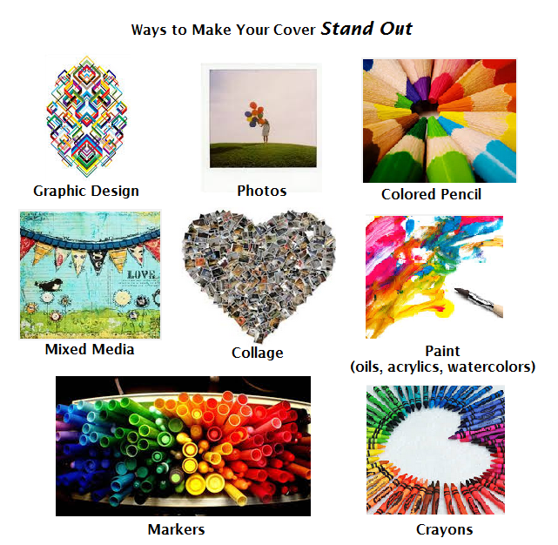

Please submit final covers to Ms. Schutter
by Wednesday, November 11

