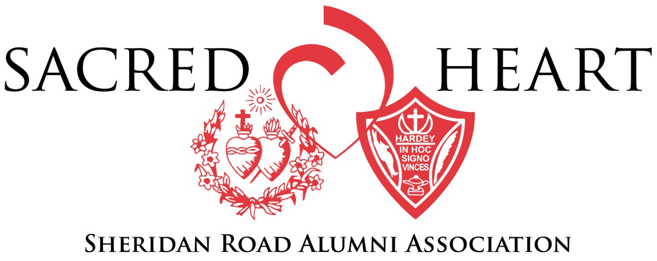

Sheridan Road Alumni Association Board Meeting
January 16, 2019 6-8 p.m.
Driehaus Center
Conference Call: 1-877-320-8506, code 28699
MEETING MINUTES
Present at Driehaus: Ann Chiumino, Joan Merlo, Mary Grady: Co-VP, Elizabeth Grady: Co-VP, Mike Pallasch, Jane Steinfels, Margo Oelerich: Secretary, Brad Gutzler
Conference Call: Mary DelGrande: President, Christine Ahern, Prep Daskalakis
- Welcome and Prayer Mary Grady
- Annual Fund Ann Chiumino
NOTES: School is on target at this point of the year! Mary DelGrande and Joan Callahan (for PAL) will send appeals letter out in February. Need to figure out target audience of who will receive the letters. All Board members should give before June 30th.

- December Events Mary DelGrande

  - Parents of Alumni Cocktail Party

    - 45 parents/former faculty and staff attended
    - Positive feedback from the event

  - Santa on Sheridan

    - 13 families attended
    - Positive feedback from the event

NOTES: Idea to add PK/SK families and promote the event as “alumni-sponsored” to drive up attendance.

- Upcoming events Ann Chiumino/Mary DelGrande

  - PAL Family Mass – March 23, 2019

    - Host Committee Members
    - Marketing
    - Board Presence – YES on Board Members attending. Mary DelGrande and Mary Oelerich will attend. O’Gradys to host, perhaps the Oeleriches?

  - L’Esprit – March 30

    - All Board members will receive an invitation, all alumni are welcome to come
    - Facebook posts

  - Young Alumni Party - April 6, 2019, pizza party at Driehaus before the musical

    - Host Committee
    - Marketing – Instagram

NOTES: No Board presence required

  - College Announcement (Reveal) Party – April 27, 2019

    - Host Committee
    - Marketing – Instagram

NOTES: Class of 2015, no Board presence required

  - Spring Congé – date TBD

    - Host Committee
    - Location

NOTES: Idea to have a Pilates class (Angela Pawlicki), then meet up at a bar (House of Glunz, Roscoe Village Pub). Include Woodlands in the event?

  - Angel Brunch – June 8, 2019

    - Board Host Committee – 2-3 members
    - Speaker Nomination(s) - James Hendele H’04 – he was class officer and President, went to Sardinia in high school to study art and architecture when he was a sophomore in high school. He lived with a family in Japan for a year, and studied at University of St. Andrews, at the same time as Prince William and Kate Middleton. There he studied biology and was in the Peace Corps in Tanzania. He then went to University of Illinois, and participated in the Medical Students without Borders in Thailand. He is currently in Chicago and completing his 4th year of transplant surgery residency. His father nominated him.

    - Other volunteers?

NOTES: Mike P., Margo. Mike will also talk to Lin Bo who was interested in being more involved, Joan Merlo volunteered for Saturday.

- Parents of Alumni Committee Ann Chiumino
  - Database: suggestion to reach out to SRAA Board members and parents of alumni to meet at Driehaus and work on getting correct information for the database

NOTES: Idea for raffle to entice people to give information before the database party so that we have a bigger “correct pool” of information from which to contact people. Issues of inputting data – Ann will need to provide excel spreadsheets with information.

Volunteers: Jane, Mary D., Mike, Elizabeth, Christine, 11-4 pm (shifts)

  - Next meeting to be scheduled in February

- Other matters in 2019? Mary DelGrande
NOTES: Joey and Christine will be attending the AASH conference at end of April, as well as another conference in May.

- Sheridan Road Alumnae/I Association Handbook Mary DelGrande
  - Comments to Ann Chiumino before February 8, 2019 for discussion at the next meeting

NOTES: Ann will re-send the Handbook

Upcoming Meeting Schedule: 2/20/2019, 3/13/2019, 4/10/2019, 5/8/2019

